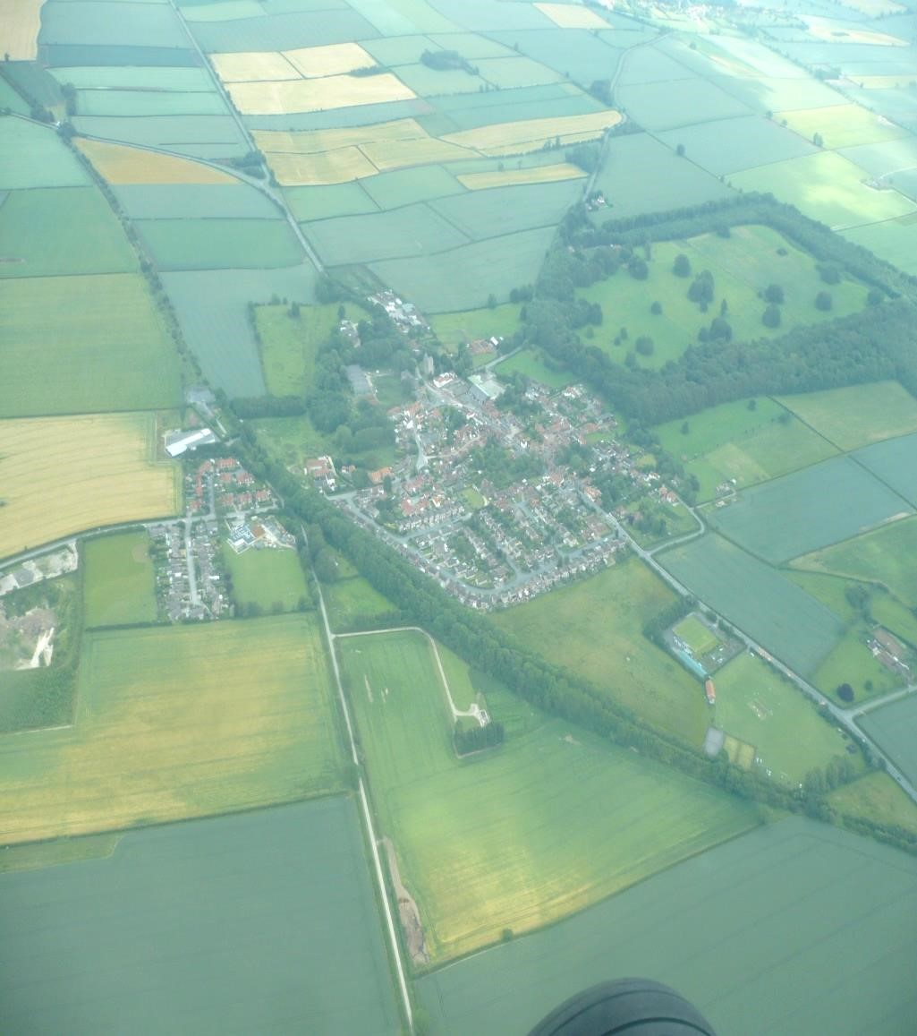

Middleton on the Wolds Community
Parish Plan 2020.

Middleton on the Wolds Community Parish Plan 2020.
Middleton-on-the-Wolds first produced a Parish Plan in 2004, which is now 16 years ago; and in late 2018 the Parish Council agreed the Plan needed to be updated in the form of a new Community Plan.
A Community Plan should outline the vision and direction for the village with a clear focus on where we want to be in the next ten years. It should be a culmination of considerable community effort which reflects the aspirations of all age groups in our parish.
The last 18 months of commitment by the Parish Council with Councillor Nick Jones taking the leading role has resulted in the publication of this document.
A questionnaire was prepared and presented to all households, followed by public consultation meetings, and four engagement activity workshops were held with the younger residents of Middleton.
Middleton is a typical Wolds village defined as a Primary village in the East Riding of Yorkshire Local Plan, with a housing allocation of 84 new dwellings. The people of Middleton should as a community have great pride in their village; and a desire to see it developed and grow in a way to serve and provide the needs of all our residents, of all ages.
I would like to thank all those involved to date, in the preparation of this document, with a special thanks to Councillor Nick Jones.
I sincerely hope you enjoy reading and studying the Community Plan, which is based on what you told us, designed to achieve positive outcomes for all who live in, work in or visit Middleton-on-the-Wolds.
John Eastwood
Chair Middleton on the Wolds Parish Council.

‘A Clear Vision for the Future’.
Middleton on the Wolds is a village which lies approximately 8 miles equidistant between the towns of Market Weighton and Driffield. The A614 runs through the centre of the village and is a very busy route which connects the motorway network at Howden to Bridlington and other east coast seaside resorts. The main body of the village lies south east of a dismantled railway line which now forms a woodland screen to the village. A conservation area was established in 2011 and covers the southern half of the village.
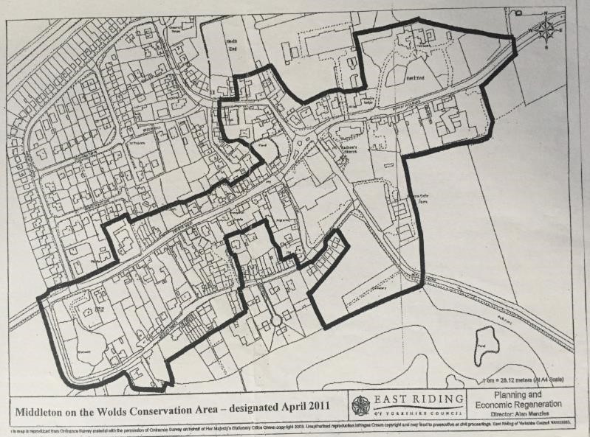

In the East End of the village lies St Andrews C of E Church and which stands on a rising slope and is a particularly significant landmark. It is a wellmaintained Grade 2 listed building and the centre for the Village’s Bell Ringers. The village has contrasts of appearance, Front Street has an urban character, whilst South Street presents as being more rural with over the past 200 years differing contrasting house styles being built. Front Street is characterised by the problems of traffic volume, speed, noise and fumes. Major efforts to obtain a village by- pass in the 1960’s, 1980’s and 90’s were not successful and the increase in HGV’s using the A614 through the village in the last 20 years has exacerbated the problem and is a current major concern for Middleton’s residents. Station Road runs through the village and past both the dismantled railway line and Quarry and leads out towards the village of North Dalton. To the east Beverley Road passes the villages Cemetery and onwards towards the village of Lund.
In order to fulfil the needs of a growing population the 1970’s saw the construction of a modern housing estate along Greenfield Road. As a modern open plan major development its design of large and medium sized houses, bungalows and semi- detached properties are in stark contrast to those of the rest of the village. However, its location is discrete, and the estate helps fulfil the diverse needs of the village’s population of 825 (2011 Census).
The village has a few local services including a Primary School, Post office and Public House, The Robin Hood. There is an active committee which oversees the Village Hall on Station Road and which is a centre for social and community events, clubs and other community functions. On Front Street the Parish Council headquarters at the Reading Rooms provides space for meetings and social group activities.
Most commercial activity takes place along Front Street with a Hairdressers on Front Street, a Post office, which in addition to postal/banking services sells basic commodities and businesses in the Courtyard developments. Soanes Poultry Company are based on Church Hill and are a wholesale provider of chickens for the trade. There is a Quarry to the north of the village. A former Land Rover garage sits on the corner of front street and chapel lane where recent housing developments have sprung up. There is a well- established Chinese food takeaway on Station Road and a mobile Fish and chip van which visits the village on Wednesdays. A mobile library also visits the village.
The village benefits from a Sports field and Recreation Club which runs successful football and cricket clubs and has a Pavilion with changing rooms. There are adjoining Tennis and Bowls clubs which contribute to the social opportunities for the village. There is a recently constructed Children’s play area for the under 11’s and aspirations to provide further sports and recreational equipment for older young people and adults soon.

Future Housing.
Middleton on the Wolds was identified as a Rural Service Centre in the East Riding Local Plan Development Document (2016) with the vision of 70 new houses to be built over the period to 2028/29 (East Riding Local Plan Allocations Document 178- Adopted July 2016). Whilst 6 dwellings have already been built on Chapel Street/South lane, a site for up to a further 64 houses have been identified for land to the east of Station Road. Any developments are subject to planning requirements/approval and are subject to Flood zone considerations, plus the safeguard of local trees and monuments.
To the south of the village the landscape is mainly woodland. A circular walk around the village is possible but with some road walking on Beverley Road. With support from local landowners and the local council the Parish Council hopes is establishing a ‘Trod’, a trodden down path along Beverley Road which will it is hoped, overcome the need to walk on the often-busy main road. Many of the village residents enjoy walking (often with dogs) along the disused railway line, with one of the 2 sections passable. This section has recently been enhanced by the efforts of local children and their parents who, under the ‘Lifestyle’ project, organised by Humberside Police, have created an area for people to sit and rest in a nice garden type area. A bench has been installed and a flower bed created. A viewpoint has also been made by the clearing of some small trees and bushes, allowing bird boxes and feeders to be installed. The Parish Council aspires to formally lease the land and manage it and both to support further community projects for the line and to improve access to the currently impassable eastern section.
Middleton has a significant amount of bird and animal wildlife, including both migrant and birds of prey and even Red Kites. Bats are encouraged by the installation of boxes and Hedgehogs are both encouraged and supported by individual local people.
Social Trends and Mobility
With the Greenfield Estate development, the population of the village doubled and at the last Census (2012) the recorded population of the village was 825, the eldest residents being over 90 years of age. The mean age was 43.1 years with the highest percentage group being between 45-59 years of age. There were 142 people under the age of 18 years and in 2019 it is estimated that there is currently 118 7 to 21 years of aged young people, of which 35 are between the ages of 7 to 11 years. 28 village pupils attend the village primary school.
Economically there are few local employers and many people of working age commute to neighbouring towns for employment including Beverley, Driffield, Hull and York. As with national trends the elder population is growing steadily with an estimated 250 residents being aged 65 years or over.
Neighbourhood Planning and Community Led plans.
In 2011, the government introduced a community’s right to undertake Neighbourhood planning through the Localism Act. It allows communities to decide the future of the area where they live and work. Specifically its vision is to allow residents to be able to-
- Decide what type and design of buildings they want (i.e. new homes, shops and offices/industrial units)
- Grant planning permission for the new buildings they want to see go ahead.
In short they allow communities to put in place planning policies for future development and growth of a neighbourhood. They relate to the use and development of land and associated social, economic and environmental issues. All neighbourhood plans are subject to the scrutiny of the local Authority (i.e. East Yorkshire) and when approved are legally binding and must be used to determine planning applications in the neighbourhood area. Neighbourhood Plans can propose more but not less than development than identified in a Community Led Plan. Policies produced will be used to determine planning applications and appeals. They have an intensely local focus and may be as ambitious or as modest as a community determines but with a focus on the design and construction of buildings.
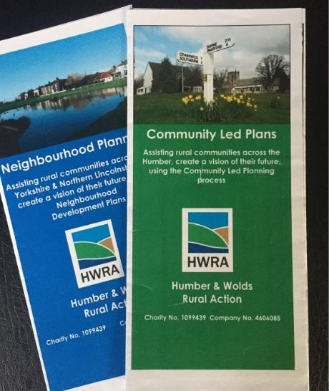
Community Led Plans.
A Community Led Plan, formerly known as a Parish Plan, is a step by step process for communities to develop a vision and plan for the future. This considers the needs of all who live and work within the community. An action Plan is developed as part of the process and which sets out how this will be achieved. Despite its name a Community Plan is not designed to deal with land use matters in detail. Community Led Plans can be produced by any size of community and on average take 12-18 months to complete. They-
- Give the community a voice to discuss/debate issues within the community.
- Identify new services that can be provided.
- Highlights issues of concern as well as what people like about their community.
- Considers ideas that can improve community facilities for all. • Supports funding applications by providing evidence of need.
A community Plan should involve as much of the community as possible and look at that communities needs for the next 5-10 years. It should be based on information collected locally and be focussed on action, stating clearly what will be achieved and by whom. It does not however consider planning applications and the Parish Council does not grant any planning permission.
Previous Parish Plans.
The last Parish Plan was undertaken in 2004 and was entitled ‘Your Village Your Future’. In order to get an understanding of what was important to the community a questionnaire was devised and 312 were distributed and 254 returned, an 81% return rate. There was also a separate youth questionnaire.
Key areas of response/concern were-
- Traffic issues including danger spots, speeding and parking. Large vehicles/trucks using the A614 was of particular concern. The Parish Action Plan hoped to agree a programme of action with ERYC with the introduction of traffic calming, speed reduction zones and more regular Police mobile camera van visits. Parking was an issue, with both more places needed and more considerate parking by all.
- Transport/Planning issues. Young people wanted more evening and weekend bus services and more elderly residents wanted to ensure bus connections to both Driffield and Beverley were maintained as it was their lifeline for shopping/visiting GP etc. There was also a strong view that older people wished to remain in their own communities and not have to move when they needed more help. Sheltered accommodation was highlighted as a potential need for some and that any future development of the village should reflect this. This remains an important consideration for pending and future housing developments. There was a view that those with special needs would benefit in the appointment (in the longer term) of a doctor or registered nurse visiting the village on a regular basis.
- Social Facilities. Young people wanted to see more youth facilities and events being held at the Village Hall and also outdoor sports facilities aimed at their age range. The Recreation club provided opportunities to both play and watch sport and was expanding. There were active Tennis, Football, Cricket and Bowls clubs and support for a concept of a new leisure /Indoor Sports centre. It was felt that the lack of youth orientated activities had led to some crime and anti- social behaviour. The Village Hall provided and continues to provide many events and functions for local people and was seen as the hub for social contact.
- Dog fouling was also an issue and a neighbourhood watch scheme was suggested as was input from the police and Dog wardens.

An action plan was devised for the above and no doubt much was implemented but no surviving written evidence of what was formally achieved could be found. It is important that any Action Plan is Specific, Measurable, Achievable, Relevant and Time bound (SMART) and also owned by a community at large and not just the few.
Middleton’s Community Plan 2020.
In the latter part of 2018 and in the light of recent legislation regarding Community and Neighbourhood planning the Parish Council decided to devise a questionnaire aimed at finding out their views on living in the village, what was important to them and how they saw the development of the village in the future. It was divided into the following sections –
- VILLAGE AMENITIES
- VILLAGE BUSINESSES
- INFRASTRUCTURE AND HIGHWAYS
- INFRASTRUCTURE (BUILDINGS)
- GENERAL COMMENTS

It is fair to say that the response to this questionnaire was disappointing. The questionnaire was launched on the Parish Council’s website but yielded only 17 responses, 5 on paper and 12 online. Fuller details of the questionnaire and all the responses are available on line ( www.middletononthewolds.co.uk), however a summary may be represented as follows-
VILLAGE AMENITIES.
  - Village Hall and Reading Rooms need updating.
  - Improved walks/Dog walks needed.
  - Convenience store needed.
  - Youth facilities – Educational/IT/Social.
  - More Wildlife areas.
  - Playgroup/activities for 7-15’s.
INFRASTRUCTURE ROADS AND HIGHWAYS.
  - Traffic and speeding. Esp. unescorted wide loads/ articulated lorries, plus their noise and pollution. Need for more speed restrictions of 20mph.Traffic ignoring speed limits and pedestrian crossing presents a danger. Calls for a By-Pass.
  - Lack of Parking and poor parking (South Street and Pickering Park when events on at Village Hall? Designated parking area for works vans? Car park at end of village? Restriction of parking time on main Streets.
  - Pavements-often too narrow and can be dangerous. Paths need to be cleaned more often.

INFRASTRUCTURE (BUILDINGS).
  - Shop/community hub needed.
  - Old Land Rover Garage an eyesore, other uses?
  - Restrict future building to be within boundary of the village and any development to include a convenience store and permanent speed cameras at both ends of the village. Buildings to be fitted with bird and bat boxes and hedgehog corridors in fences and walls.
GENERAL COMMENTS.
  - ‘Great village to live in but main road too busy with too many heavy goods vehicles using a road which was clearly never designed for that type of traffic.’ (This comment repeated many times!)
  - ‘Christmas lights a great success’.
  - ‘Communication is an area we could all improve on’
  - ‘A new village hall could be central to fostering a community spirit’ ‘The village needs a heart’
  - ‘Not enough is done to look after wildlife…a village ban on all poisons…and a focus on natural predators instead
(Hedgehogs, Owls, frogs etc.)’
  - ‘…In short to get everyone work and share together, including school fund raising activities’
  - …I am not aware of any dedicated youth facilities, both recreational and educational. E.g. facility for access to computers/IT library’.
Further Public Consultation.
Given that the questionnaire response was relatively poor it was felt that further and wider consultation was needed to be gathered from all residents of the village, whatever their age. As land allocation for new housing had also occurred in 2016, there seemed little point in working towards a larger building orientated Neighbourhood Plan whereas a Community Plan aimed at meeting the identified needs and concerns of the villagers would be a better fit and could be ‘owned’ by all the community. As a result 2 public consultation meetings were held in the Reading Rooms in January 2019 and further to that 4 consultation/ engagement activities were held between April and September with the younger residents of Middleton.

PUBLIC MEETINGS.
To ensure that as many residents as possible could attend 2 Public meetings were held, 1 on a Saturday morning the other the following Monday evening. A total of 23 people attended. They were invited to comment on the results of the questionnaire followed by an open discussion of issues that were important to them.
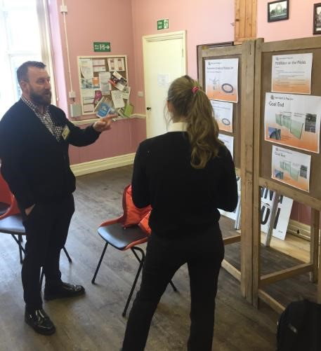
In addition to the questionnaire comments (most of which were agreed with) the following key points were added-
VILLAGE AMENITIES.
- Community Centre/Training venue (to bring new people to the village)
- Greater ‘Green’ and wildlife policies around the village.

VILLAGE BUSINESSES.
- Local shop/Deli to act as Community Hub required.
INFRASTRUCTURE ROADS AND HIGHWAYS.
- Wild flower verges around the village.
- Improved bus services needed.
- Air quality testing to see if proportional to traffic density. • Strategic plan needed to divert HGV’s away from A614 and wide loads only with an escort.
INFRASTRUCTURE BUILDINGS.
- More housing and therefore more amenities to support them
(e.g. Dr’s surgery, Police Station etc.)
- Any new housing developments to include land for possible new Village hall (with parking spaces).
GENERAL COMMENTS.
- Maintenance of railway line and embankment.
- Much more wildlife and green policy activity (esp. tree planting).
- Invite Landowners/investors in village to participate in Village plan.
- Greater community spirit required.
- More sports facilities for older children/young adults needed.
What seemed to be emerging was a desire to retain the village’s character whilst supporting limited development but with a high emphasis on community involvement and the venues to support it. Of particular concern was environmental issues of noise, traffic and speed and also a desire to promote more green and healthy initiatives in the village.

Throughout the consultation process there was an absence of contribution and views of the young people of the village. Our young are our lifeblood and they are the future of any community and so their views on how to shape its future are very important. All must be heard and with that aim in mind it was decided to set up a series of engagement and consultation initiatives aimed at 5-18 years of age young people. In order to do this, it was important to involve our local school and to engage with young people in age appropriate ways using methods with which they could connect with. As a result, the following was set into action…
YOUTH INVOLVEMENT.
Young people between the ages of 11-18 attend a total of 4 local schools and so the task of engaging needed to be localised. Contact was made with EYRC Youth and Family Office and a partnership formed with a Community and Partnership Officer who helped set up a Bus Stop Canvas (and ensured all safeguarding procedures were followed). A questionnaire was designed and assisted discussion with volunteers as they got on/off the school buses.
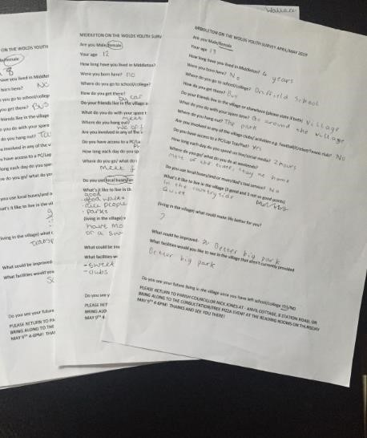
The 10 respondents were aged 12-18 years, 60% female, and 40% male. The majority were not born in the Village but had lived there most of their lives. They travelled to school by bus and car and the same in their spare time. All had access to a PC/Laptop and spent an average of 3+ hours a day online/engaged with social media. None of the respondents were involved in any of the clubs/activities in the village but this was not a problem for them and they did meet friends and’ hang out’ in the village park. There was a general view that Middleton was a good place to live, was friendly, quiet and enjoyed the countryside. They felt the downside was lack of transport, lack of social things to do and some occasional boredom. Asked what could be improved the following were recorded-
- Bike Park/tracks.
- Dog walks
- Bigger and better parks for teenagers/young adults.
- Social club.
- Shop/sweet shop.

In order to expand on these responses and to hopefully engage other young people the respondents and were invited to join in an after school village-wise advertised free ‘Pizza and Soft Drinks Party’ which was held at the Reading Rooms a short time afterwards. This would also provide an opportunity for young people to express their views and preferences for play and exercise equipment that the Parish Council was hoping to get grants for a new Park project within the village. Unfortunately this was poorly attended with only 4 young people attending but their contribution was positive and constructive. They were asked to address what were in their eyes both the good and not so good points about living in the village together with ideas about what they would like to see in the future.
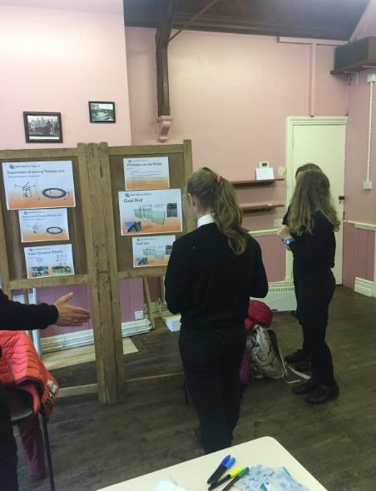
The group reiterated that Middleton was a nice place to live, was friendly and had lots of space/playing fields. They liked the duck pond and felt that nature was important and like walking on the old railway line. They felt safe (all female respondents) in the village.
They were less happy about the traffic and felt that it was too busy and that ‘no one slowed down’ when driving down the main road. Questions concerning the amount of caravans passing through the village were raised as was the pollution that large vehicles produced. Some felt that the Chicken factory ‘smells’. Public transport was an issue with too few buses, particularly at the weekend and that they relied too much on mum and dad’s taxi service. A desire for a shop was again expressed and that perhaps a Youth group might be an asset in the village.
The group suggested a bypass for the village and crossings near the top of the village/outside the park. As this was unlikely Speed cameras were also suggested and better traffic management. A nature trail was high on the list as was a shop and again a bike trail. It was recognised that a swimming pool was not a realistic option but still desirable!
The group wished there was more part time job opportunities for young people.
There was great enthusiasm for exercise/ play equipment and the notion of a new park to house these, stressing that it would be a good opportunity for young people and adults to undertake such activities together and to show their parents what they could do!
In addition there was a strong call for more trees and litter bins to be placed in the village.

YOUNGER PEOPLE’S INVOLVEMENT.
The under 12’s views on most subjects are not often heard but are no less important in shaping the village for the future. Following a meeting with the Head Teacher it was decided to repeat the consultation exercise using the survey headings with a year 5/6 group of pupils along with their teacher. This group was no less vocal than that their older peers and there was concern about traffic issues, speed and pollution. All likes living in the village and liked being able to play out in the park. A bike park/track was high on their list of what they would like to see provided as was a Zebra crossing outside of their school. Nature was important topic of discussion with a desire for more trees, bat and bird boxes being provided and a greater use of the old railway line for preservation and recreation. (Pic of school focus group)
In addition to this group and on a separate occasion in September a Parish Councillor met with the School council which is made up of representatives from years 1 to 6 (7 girls and 5 boys). In this open discussion they too were concerned about protecting green spaces in the village and encouraging more wildlife to thrive in the area. They requested a new play area which contained a football goal. They too would like a (sweet) shop in the village with one ambitious suggestion that a Chocolate Factory be established in the village!
In order to capture the opinions other children a smiley face survey/questionnaire was given to all 28 pupils in the school who lived in the village with 100% response rate.
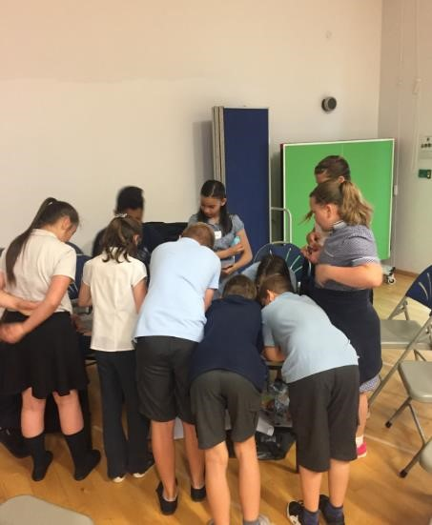
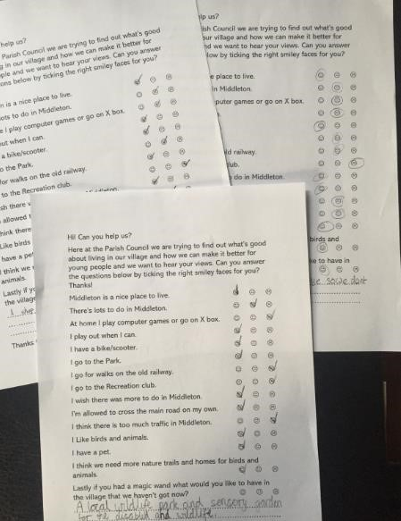
The top score responses can be summarised as follows-
I have a bike /scooter…..26
Need more nature trails/ homes for birds and animals…..26
I like birds and animals…..25
I have a pet…..24
Middleton is a nice place to live…..24
I play out when I can…..20
I wish there was more to do in Middleton…..19
I go to the Park…..17
At home I play on Computer/X box…..15 And the unhappy faces…..
Too much traffic in Middleton…..15
I’m not allowed to cross the road on my own…..9
The children were also asked if they had a magic wand what they would wish for in the village. The top responses were…..
- A shop (14)
- New/improved park (8)
- Bike/Skate park (4)
- More buses (3)
- Solar Panels + a Zip wire (2 each)
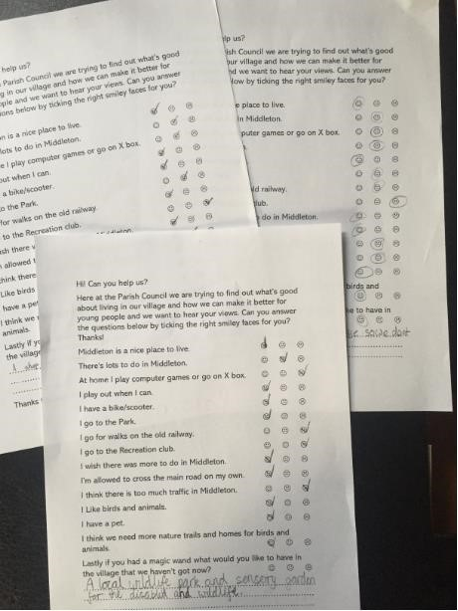

DRAWING IT ALL TOGETHER.

There is no doubt that despite attempts to involve all sections of our community both the founding Questionnaire and subsequent public meetings did not attract as many responses as it did in 2004. This was disappointing and may reflect several factors including the suggestion that there is less community spirit and involvement than there has been in bygone years. Collectively our lives have never been so busy and certainly that appears to reflect a shortage of response by us either electronically or in person. In particular the response of working aged adults in our community was particularly low. It may reflect a content with life in our village and that generally it’s a good place to live and we are getting it largely right. It may also reflect that many still find it difficult or uninviting to respond to questionnaires that are on- line and that paper still rules in many people’s lives!
The members of our community who did respond had some powerful messages for us all to consider and those from the younger members of our community in particular they need hearing and acting upon. They are messages that affect us all, those about environmental issues, traffic, pollution and the need to protect and promote our wildlife for our and our children’s future generations. The following Action Plans are a suggested start that ALL OF US need to be involved with as it’s our joint responsibility and not that of a few to ensure that our village is a good and healthy place to live and that our children will want to continue to live in beyond our lifetimes. The Actions Plans are not exhaustive and will need to be constantly reviewed, tweaked and added to in the months and years to come. Please consider them and what your contribution can be towards fulfilling them.

ACTION PLANS.
Traffic Volume, Size and Speed

Action Points | - Engage with East Riding Police and safer Roads Humber to raise awareness of concerns and to discuss possible interventions- Speed humps, strips, installation of fixed cameras, improve signage etc. This to include lobbying for a Pelican  Crossing and possible traffic light control on Front Street. To be aware and monitor other traffic safety concerns,  Particularly where young people cross roads to catch school buses.  - In partnership with Safer Roads Humber set up a Speed watch Group within the village to target problem areas. Collect evidence of any disregard of highway rules.  - Consider wider impact of traffic in village i.e.  health/pollution.
Who Will Undertake? | - Parish Council to engage with Police/County Councillor and to pursue possible solutions.  - Parish Council with EYRC to set up Speed watch to be staffed by (trained) volunteers from the village community.  - Discuss with EYRC possibility of pollution monitoring.  To seek/invite community/local schools to support and to set up ‘Keep Your Village Tidy and reduce Plastic usage’ initiative.
When | Throughout 2020. Speed watch to be running by Summer.  Clean air survey by summer 2020.
Achieved/Reviewed | Review monthly via PC meeting and invite Police/local Councillor to quarterly meetings. Update community via Website and inclusion in monthly Messenger newsletter.
Costs | Set up cost of speed watch (minimal) and Volunteers time
Improved Play Area for all

Action Points | Parish Council to scope and consult community on proposed improved play area at the Recreation Club. A survey to be delivered to all homes in village to ensure wide consultation.  To consider a possible ‘bike track’ as part of the plan as funding and space may allow or in the future.
Who Will Undertake? | Nominated Parish Councillor to lead on survey and to propose improvements (subject to sufficient funding being sought and obtained by Parish Council) and to encourage involvement by community by joining Project Steering Group.
When | Survey to be distributed in Spring 2020 and findings published by Summer.  Parish Council to apply for grants with goal of completing project by end of year.
Achieved/Reviewed | Review survey outcome once completed and review project as standing order on monthly Parish Council meetings.
Costs | Realistic costings in excess of £100,000.

Making our village ‘Greener’

Action Points | Establish a village ‘Community Nature Group’ to co-ordinate and implement a range of green and wildlife projects within the village. E.g. Tree planting/siting of Bird and Bat boxes and to raise funds for these projects. To build upon the current project ‘Lifestyle’ project along railway line/to provide and maintain bird food etc. To further develop the disused railway line and to provide dog walks for our 4 legged friends (and owners). To encourage wild flower planting on our verges and open spaces.  To actively protect and where necessary apply for preservation orders on village trees that become under threat from either individuals or Land development plans.
Who Will Undertake? | Parish Council to take lead in setting up a Group but which to be then run by volunteers from within the community.  To involve our local school in these projects via link teacher and councillor plus volunteers working in partnership with school.  Parish Council to monitor planning applications and that preservation restrictions are adhered to.
When | Ongoing throughout 2020/21 with monthly updates via Council website and Messenger newsletter.
Achieved/Reviewed | As outlined
Costs | Volunteer time plus Fund raising for projects as required.

Working together as a community.

Action Points | 1. For all of us to consider how we can make a positive contribution to life in our village. 2. To come together more via community events and to communicate with each other effectively with a shared responsibility. Parish council to consider their role in public engagement and to be more visible to the general community.
Who Will Undertake? | Parish Council to call for all the community young and not so young together with its wider stakeholders e.g. Land and business owners, Young Farmers etc.) to make an active contribution to the issues outlined and others as they emerge in the next decade. Parish council to be more visible in the community by use of photo boards/pictures and holding community engagement events so everyone is aware of who the councillors are and how to contact them. The council should encourage the community involvement and be active in promoting community projects.
When | 2020-2030
Achieved/Reviewed | Ongoing via Messenger and evidence of increased community involvement. (e.g. attendance at community events and funds raised)
Costs | Time and commitment from us all.

To keep sight of other concerns/issues.

Action Points | Record and when opportunity arises to campaign for other identified needs. E.g.  - Transport issues, esp. frequency of bus services.  - Possible Neighbourhood Watch schemes to combat crime/house break-ins.  - Community Hub/Shop.  - Future needs of our senior citizens- housing/sheltered accommodation to be considered/included in future Housing developments in the village.  - Being aware of the vulnerable adults in our community.  Hearing and supporting the voices of our young.  E.g. Safety at school and around our community.
Who Will Undertake? | Parish council to be aware of and actively influence any planning application for housing/business developments in the village to include our elderly and vulnerable. To nominate a Parish Councillor to have responsibility for any vulnerable adults and to work with other agencies as required to help support them.  Encourage the community to ‘Look Out’ for each other/neighbours and to support any community led efforts to set up Neighbourhood watch schemes
When | 2020-2030
Achieved Reviewed | Bi annual review (June and December each year) of unmet needs via Parish Council and where possible to take action as opportunity arises.
Costs

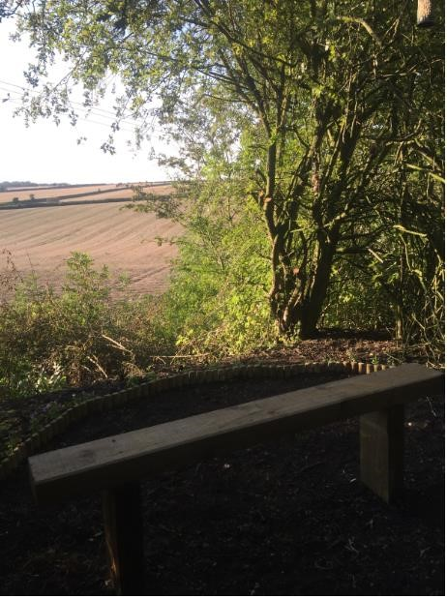
Nick Jones Middleton on the Wolds Parish Councillor ACKNOWLEDGEMENTS.
- UK Census 2012.
- EYRC Youth and Family Officer.
- Middleton on the Wolds C of E Primary School, pupils and staff.
- All the members of our community, young and not so young, who gave their time and attended the Public meetings/Youth consultation events.

